EXP 9: CREATE A VIRTUAL HARD DISK AND ALLOCATE THE STORAGE USING VM WARE WORKSTATION.
DATE: 3-10-2025
AIM:
To create a virtual hard disk and allocate the storage using vm ware workstation
PROCEDURE:
STEP 1: GOTO VM WARE WORKSTATION.
STEP2: RIGHT CLICK THE VM AND GOTO THE SETTINGS.
STEP 3: ADD HARDWARE WIZARD AND SELECT SCSI AND CLICK NEXT.
STEP 4: CREATE NEW VIRTUAL DISK.
STEP 5: SELCT THE DISK SIZE AS 2.0. AND SELCT SPLIT VIRTUAL DISK INTO MULTIFILES.
STEP 6: GIVE NAME AND CLICK THE FINISH.
IMPLEMENTATION:
STEP 1: GOTO VM WARE WORKSTATION
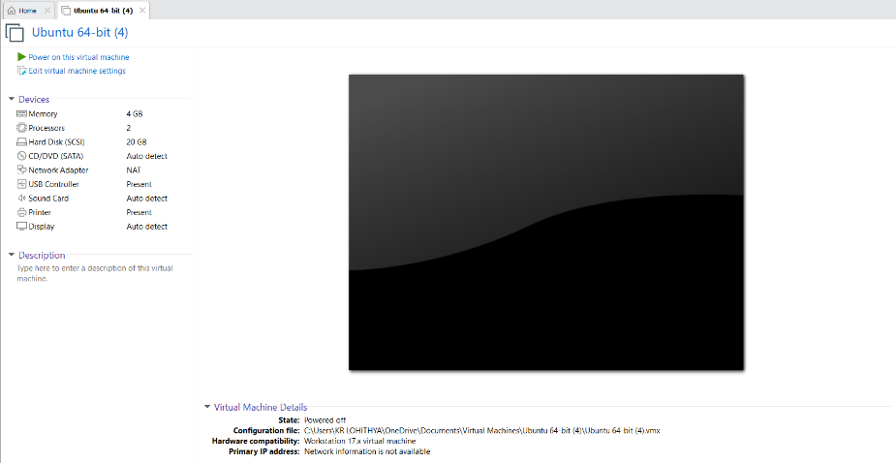
STEP2: RIGHT CLICK THE VM AND GOTO THE SETTINGS

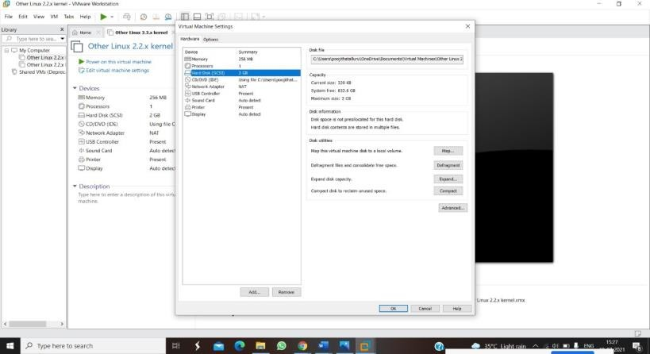

STEP 3: ADD HARDWARE WIZARD AND SELECT SCSI AND CLICK NEXT

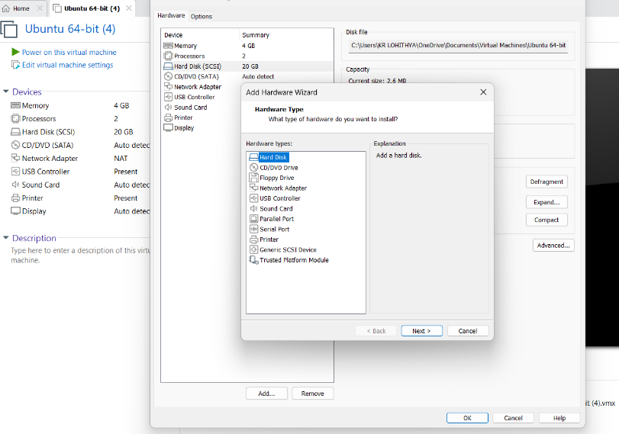

STEP 4: CREATE NEW VIRTUAL DISK

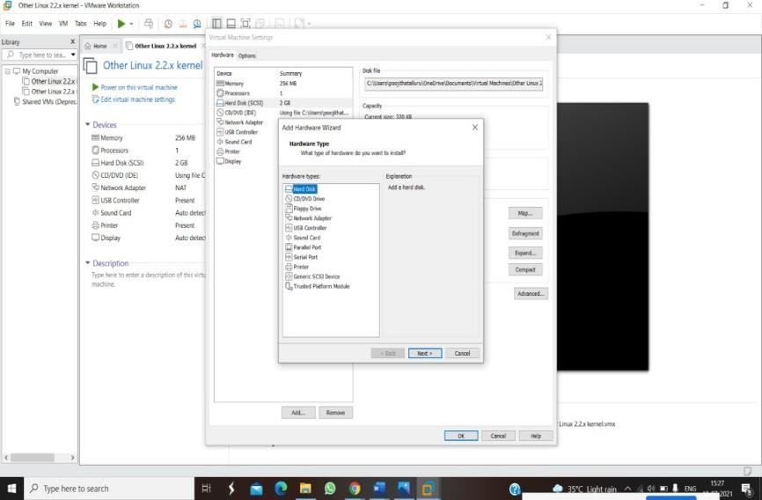

STEP 5: SELCT THE DISK SIZE AS 2.0. AND SELCT SPLIT VIRTUAL DISK INTO MULTIFILES

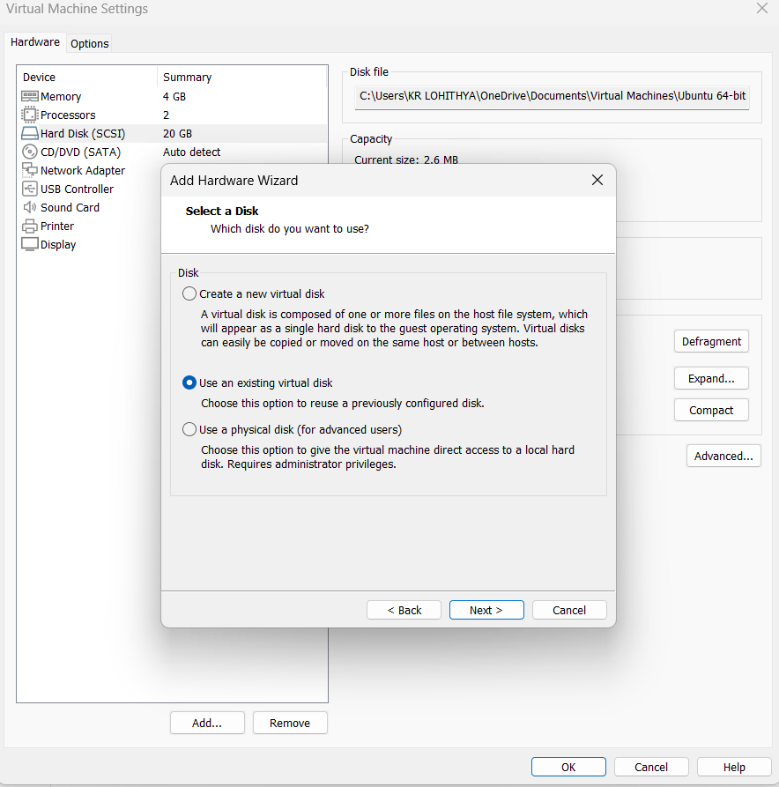
STEP 6: GIVE NAME AND CLICK THE FINISH

